**Number Two**

Describe, aided by a drawing, the functionality of a Form based user interface to a database.

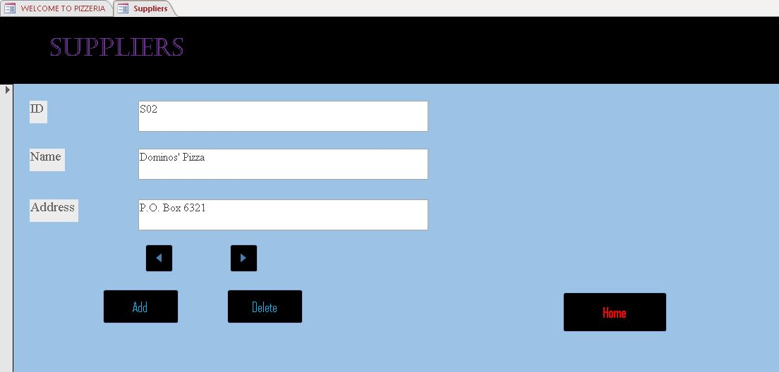

The above Suppliers Form Based User Interface, is an input form to Pizzeria database where records of suppliers are stored. One is able to move to the next and previous record. An Add button to add a record or information about a supplier, a Delete button to delete a record. The Home button sends the user to the homepage, Welcome To Pizzeria.